Yesodey Hatorah Girl’s School, Stamford Hill, North London

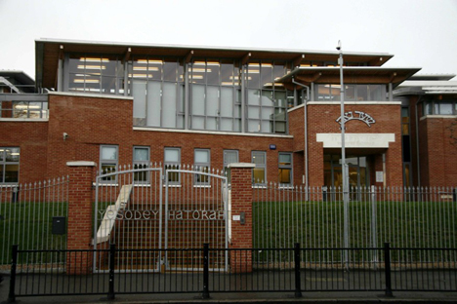
These are interesting times for the ultra-Orthodox community in Britain. The community has been growing at a dizzying rate. More than half of the children in Jewish education today are ultra-Orthodox, even though the community itself constitutes only one-tenth of the Jewish population in Britain (about 300,000 people). New schools have been opening throughout Stamford Hill and Golders Green, the neighbourhoods where the community is concentrated in London, and the number of Jewish pupils enrolling at these schools is increasing.
Yesodey Hatorah Girl’s School in Stamford Hill, North London serves the Charedi (ultra-Orthodox) Jewish community. This community is distinguished by cultural differences and strict adherence to and practice of Orthodox Judaism. All members of this community lead an extremely modest way of life and every aspect of their lives is governed by the codes of Torah observance. Charedi homes do not have TVs and parents will ensure that their children will not have access to the internet and any other media which do not meet the stringent moral criteria of the Charedi community. Families will also dress at all times in accordance with the strictest standards of Tznius (modesty) as laid down by the Rabbinate of the Union of Orthodox Hebrew Congregations.
Some 250 girls aged 11 to 16 are now studying in the spacious school, whose establishment was funded almost entirely by the government. The Headteacher, Rabbi Abraham Pinter says: “The government made it clear.. that the values of the ultra-Orthodox community, which for me stand above everything else.. would not be harmed as a result of joining the government aid scheme… For example, we received permission to excise a number of passages from textbooks that mention that a boy and a girl meet at a cinema. After all, our children don’t do that… As far as sex education goes, in Britain the parents determine whether they want their children to get this at school. With us, all of the parents don’t want this.”
“Even the authors of the GCSE exams are considerate of the ultra-Orthodox community’s sensitivities during the writing process. They invite representatives of the community to consult them about what topics to use. In addition, when we get the exams we have special permission to open them exactly five minutes before the national exam time to see whether anything appears in them that is contrary to our values. If so – for example, a question in biology which deals with sexual relations in animals – we will instruct our students to ignore it, despite the damage to their grade.”
The school made headlines in 2008 when 9 of its Year 9 girls refused to answer questions in their SATS English exam on Shakespeare because they believe he was anti-Semitic. As a result the school’s ranking in the SATS league table fell from 1st place in 2007 to 274th place in February 2008. Headteacher, Rabbi Pinter, responded: “I’m really proud that our kids are prepared to take the consequences of their convictions and I think it is something that needs to be encouraged.”
The school’s achievements are even more remarkable in light of the fact that the students do not even need high grades in order to be accepted for university – nearly all of them go on to religious teachers’ colleges and only few of them work after they are married.
The school is ranked among the top 10 in the UK and Rabbi Pinter notes that “we are successfully managing to combine the Jewish values with the British values in the national curriculum.” In 2007, two girls at the school received the highest grades nationwide in a new subject the government introduced in an attempt to combat extremism among the Muslim minority: civics. Rabbi Pinter argues that Jewish children should be taught in Jewish schools and that assimilation is something to be avoided and that Jewish schools should be a model for other communities, especially the Muslim community: “Note that the Muslims who chose to carry out terror attacks against their British countrymen went to state schools and not to religious schools. Had they attended Muslim religious schools, which build a sense of self-respect, the extremism in Britain would have decreased. He continues: “in the wake of the Muslim terror, there is now greater pressure to create shared schools where students from different religions study together” and that this is cause for grave concern.

Adapted from an article by Assaf Uni.

